Consider the following tables Client and Bill. Write SQL commands for the statements (i) to (iv)

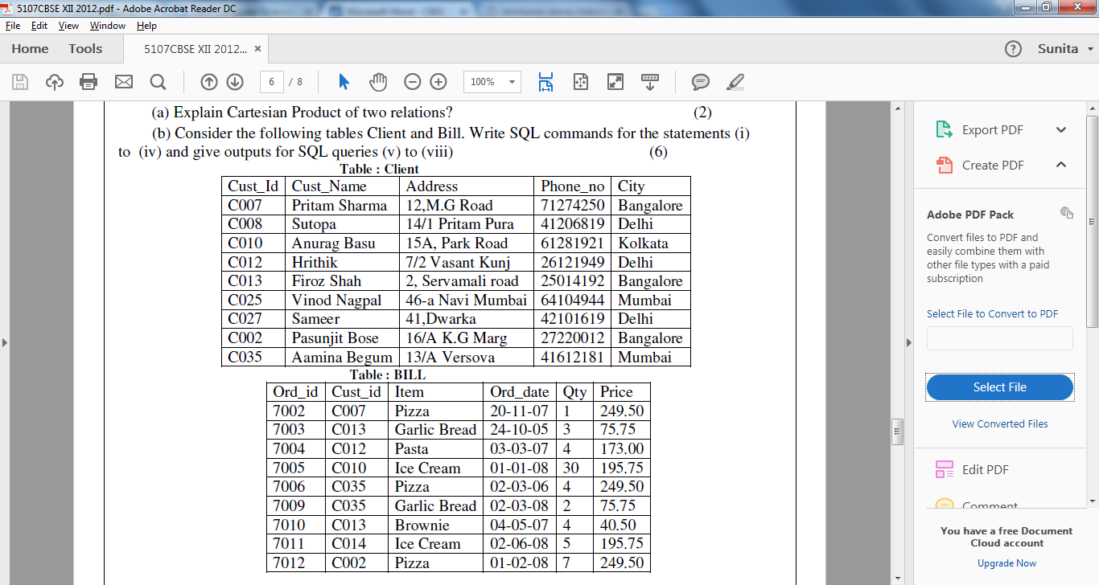

1. Display a report containing cust_id, cust_name, Item,qty,price and bill amount. Bill amount is calculated as the sum of qty*price
2. Display how many customers have ordered Pizza in the month of March.
3. Count the number of customer who have ordered item worth more than 1700. Total amount = sum of qty* price
4. Display the name of customer along with their city in alphabetical order of city.
5. Increase the price of Pizza by Rs 50.

Consider the following tables PRODUCT and CLIENT. Write SQL commands for the statement (i) to (iv)

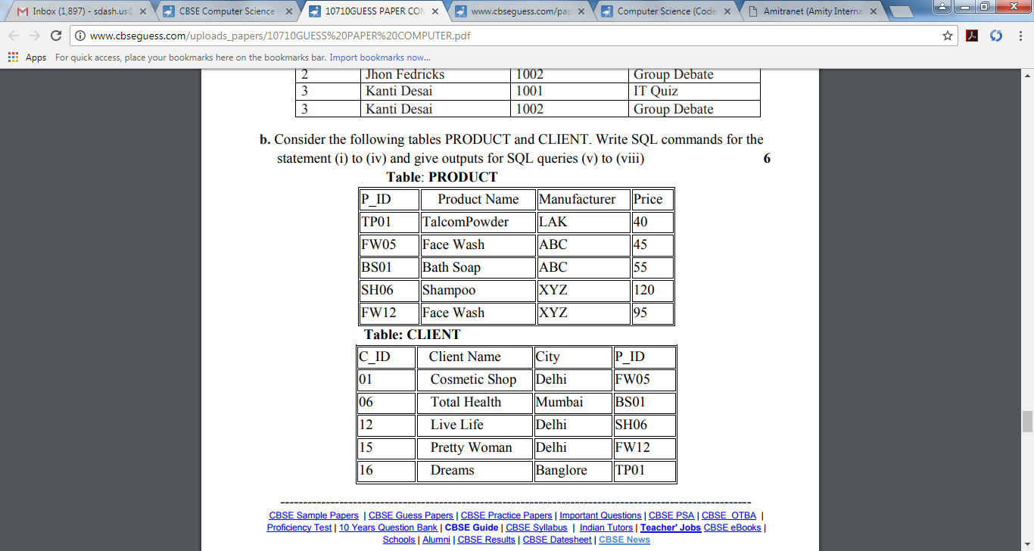

1. To display the details of those Clients whose city is Delhi.

ii. To display the details of Products who’s Price is in the range of 50 to 100 (Both values included).

iii. To display the ClientName, City from table CLIENT, and ProductName and Price from table PRODUCT, with their corresponding matching P_ID.

iv. To increase the Price of all Products by 10.

v. Count the number of products in the table PRODUCT.

Write SQL command for (a) to (d)

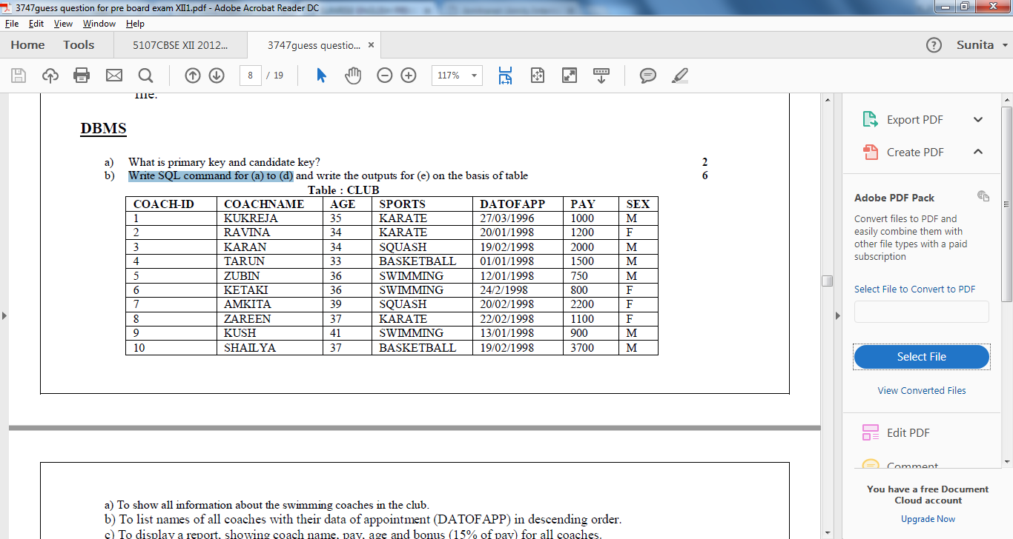

a) To show all information about the swimming coaches in the club.

b) To list names of all coaches with their data of appointment (DATOFAPP) in descending order.

c) To display a report, showing coach name, pay, age and bonus (15% of pay) for all coaches.

d) To insert a new record in the CLUB table with the following data:

11,”Rajender”,25,”Football”,{27/05/2004},4500,”M”

e) To increase the Pay of all KARATE Coaches by Rs 500.

Write SQL commands for the queries (i) to (iv) based on a table COMPANY and CUSTOMER.

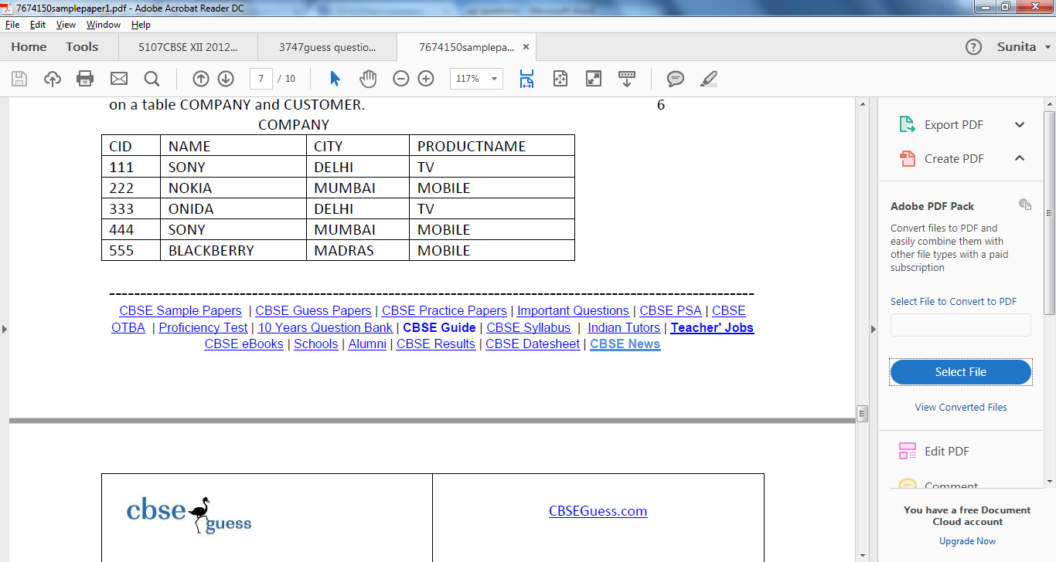

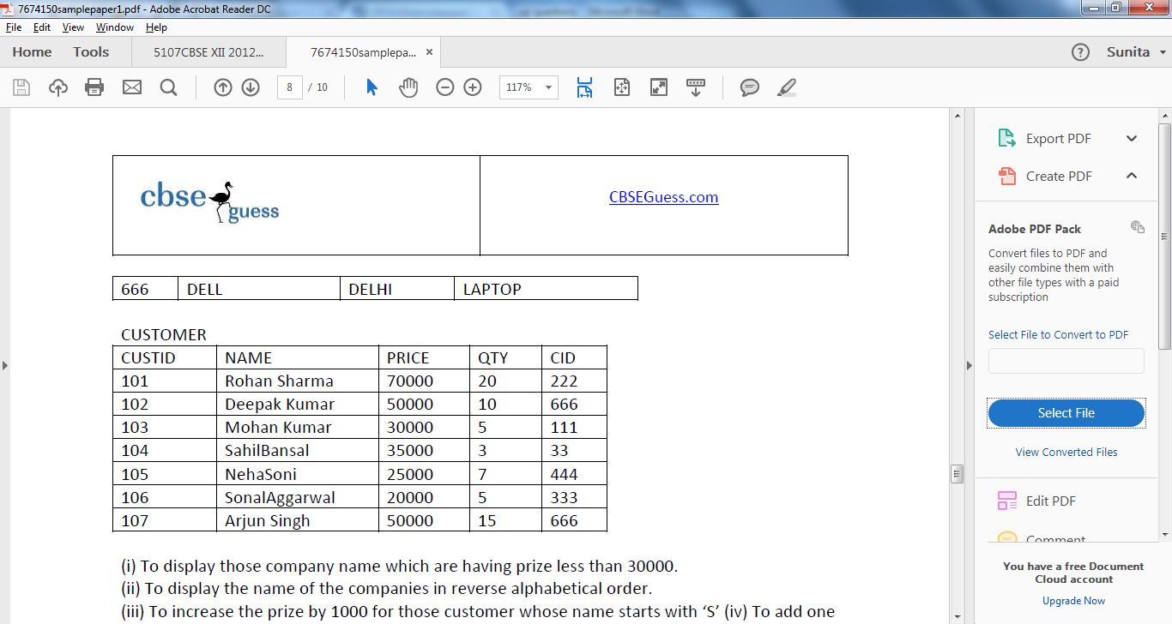

(i) To display those company name which are having prize less than 30000.

(ii) To display the name of the companies in reverse alphabetical order.

(iii) To increase the prize by 1000 for those customer whose name starts with ‘S’

(iv) To add one more column totalprice with decimal(10,2) to the table customer

1. To display the total bill(PRICE*QTY) for all customers.